Global Defaults

In relation to the default bevel position this can be updated in the VCAGlazer program. This will set all edges to these as the default. The VCAGlazer program should be found in the progs folder. Please advise if this is not available or installed.

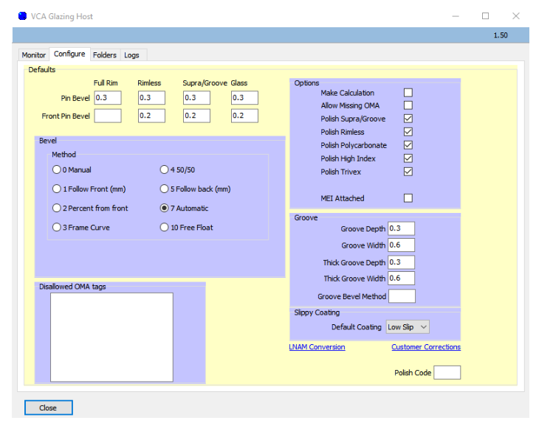

At the top of the screen there is a Rear and Front Pin Bevel/Safety Chamfer. This can be set to the required measurement in 0.1 steps of a mm. Next is the bevel position. This is the global default for where the bevel will be placed in relation to the frame. Most of our customers set this to 'Automatic' with the newer machines. Under the 'Options' selection you will see polish options. 'Groove' allows you to specify the Depth and Width for standard and thick supras. This measurement is again in 0.1mm steps.

If you have other questions about the global defaults please let us know.

Amending Individual Orders

If you have an individual order that you wish to amend the positions on, this can be done via VCADevice. From the VCADevice program you can search for the order on the 'Jobs' tab. This will then allow you to change the options visible on the Frames tab and save for that live order.
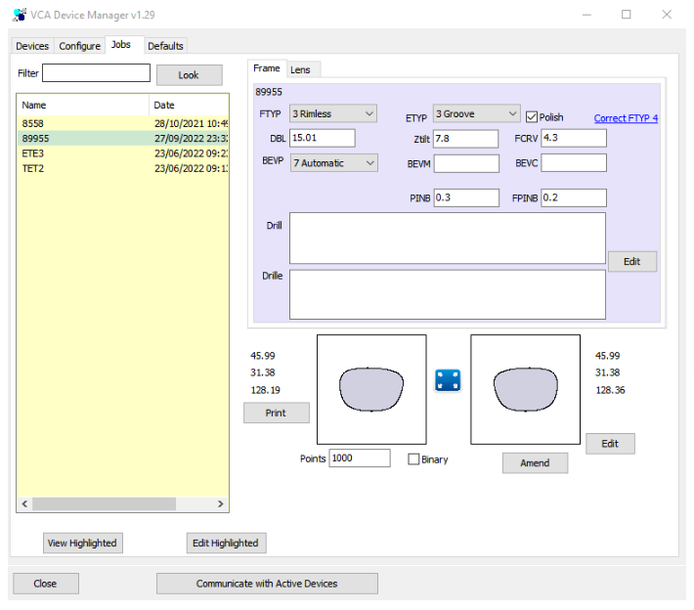

Order Entry

It is also possible to set these in order entry if a shape trace is available.

Clicking on the Bevel link will bring up the panel below where the position can be entered.

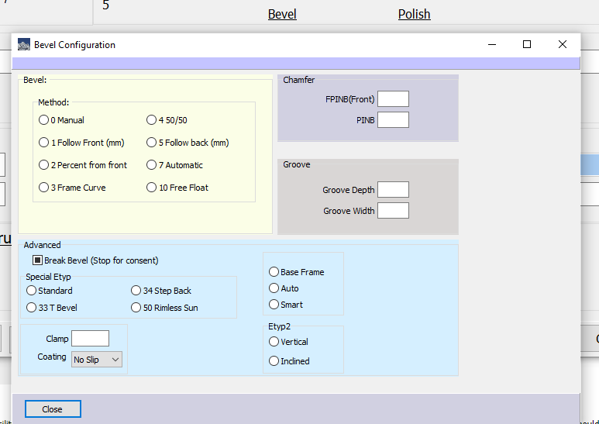

Size Offsetting

In relation to the size offset of orders can you confirm what this is for? We have a facility that will allow you to offset for specific customers but this is the exception rather than the rule. All edgers should be calibrated and sizing should be adjusted so that there is a minimum requirement for adjustment. Please provide more information on this so that I can advise accordingly.

